Kavya Gundala

03-01-2024

**Delta Lake:**

* Delta Lake is the optimized storage layer that provides the foundation for storing data and tables in the Databricks lake house. Delta Lake is open source software that extends Parquet, csv, json data files with a file-based transaction log for ACID(Atomicity, Consistency, Isolation and Durability) transactions.
* Delta Lake is fully compatible with Apache Spark APIs, and was developed for tight integration with Structured Streaming, allowing you to easily use a single copy of data for both batch and streaming operations and providing incremental processing at scale.

**Creation of Cluster:**

* For today’s workspace we create a cluster named “Kavya_cluster” in Community edition. Open a notebook and start executing delta lake commands.

**Load a table:**

* All tables created on ADB are by default delta tables. Now load a table from the databricks-datasets that is present be default. Give the table name as “people_10m”. Below table is created in Python.

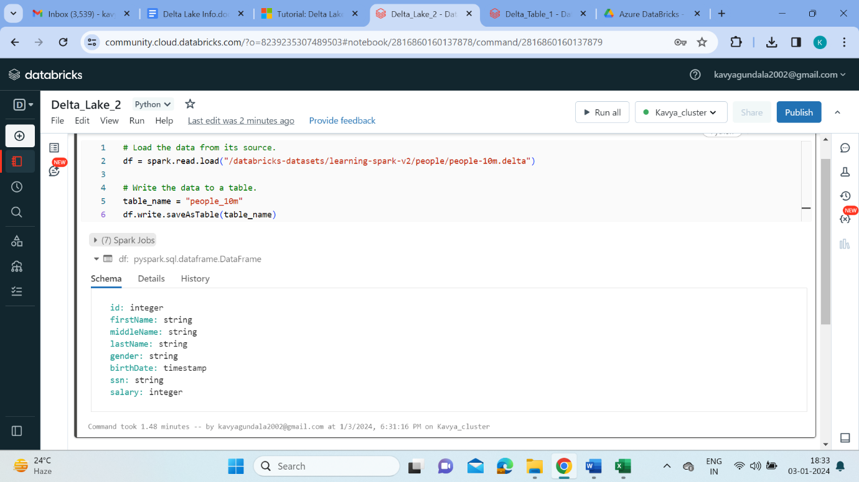

* Now click on the ‘+’ down the cell to open a new cell. We try to create the table “people_10mS” in SQL language. In this way we can create delta tables in R as well as Scala language.

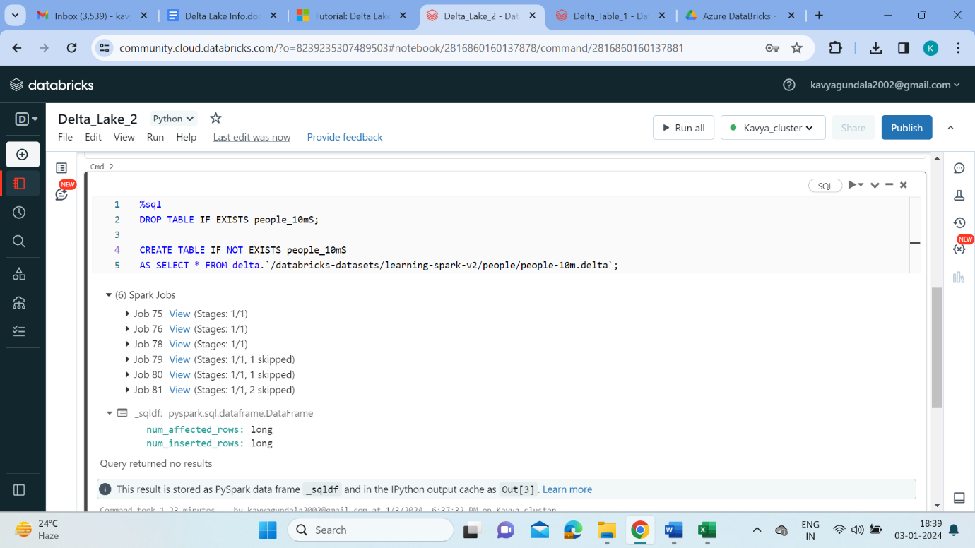

**Describe table:**

* For managed tables, Azure Databricks determines the location for the data. To get the location, we can use the DESCRIBE DETAIL statement, for example the below command is written in SQL. Here onwards we execute commands in SQL.

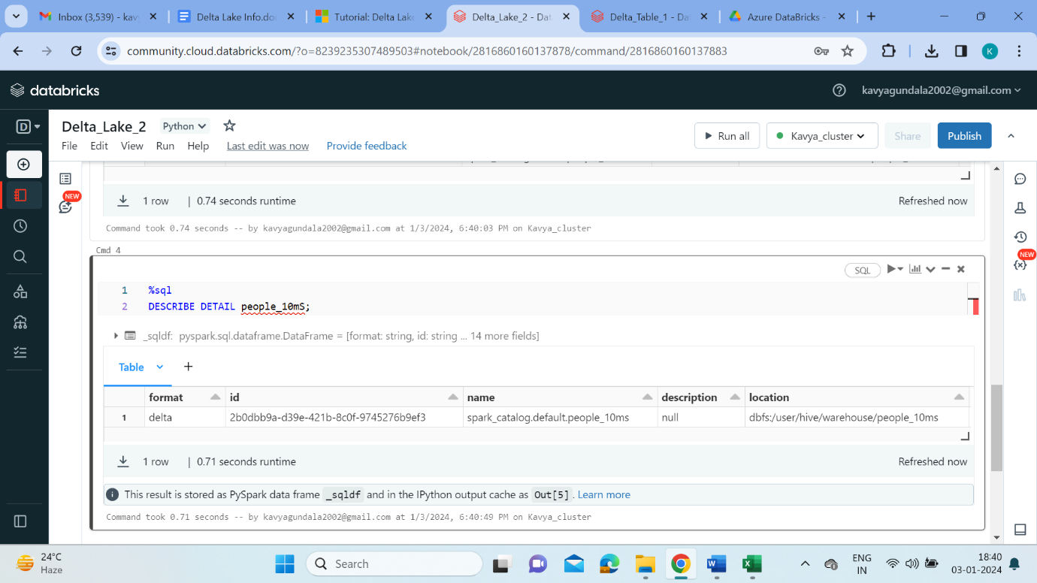

**Create a table:**

* Now let’s see the creation of delta table by user in SQL. Create a table called “people_10m” with the respected attributes as shown below. Then the table gets created and outputs as OK.

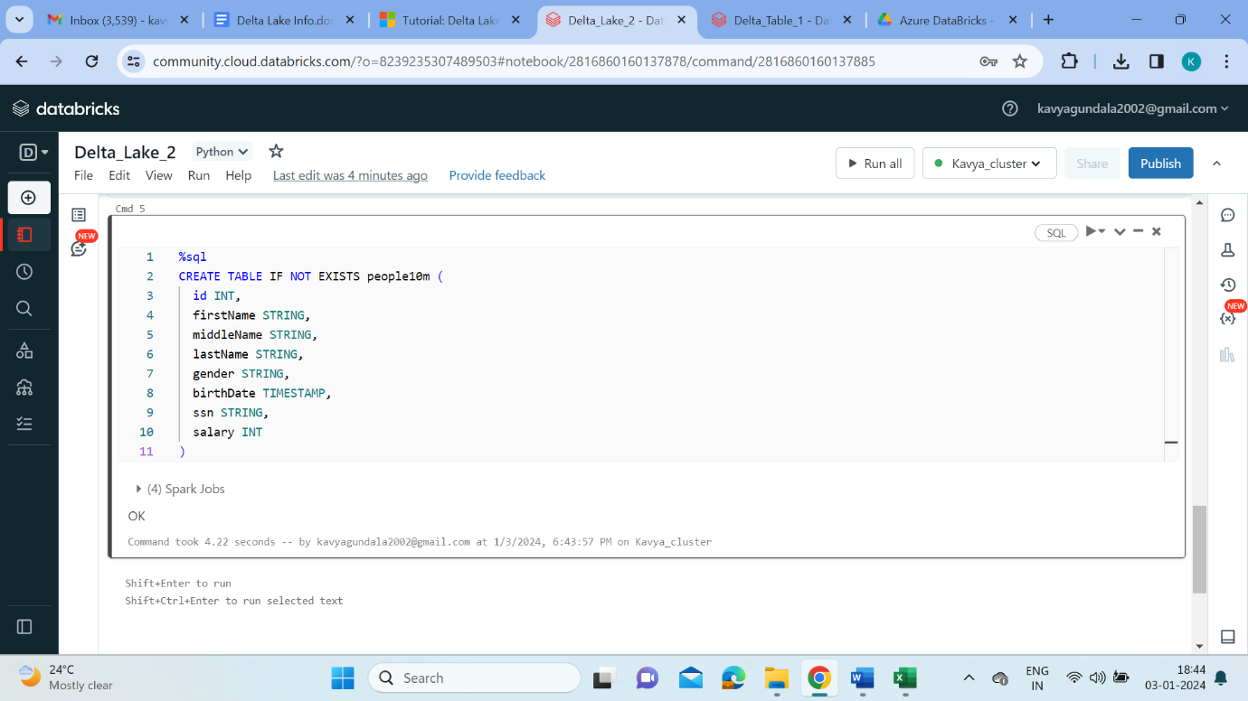

**Upsert to a table:**

* Upsert is a operation when insertion and updation is done at a time to an existing table. We do upsertion on the below table in the following way.

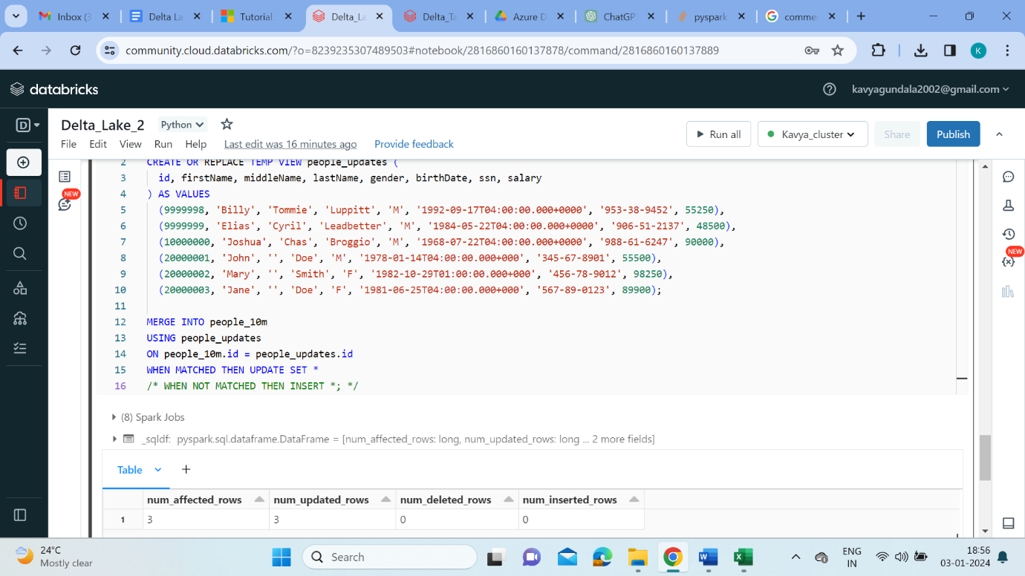

* To see the results, we run the below query.

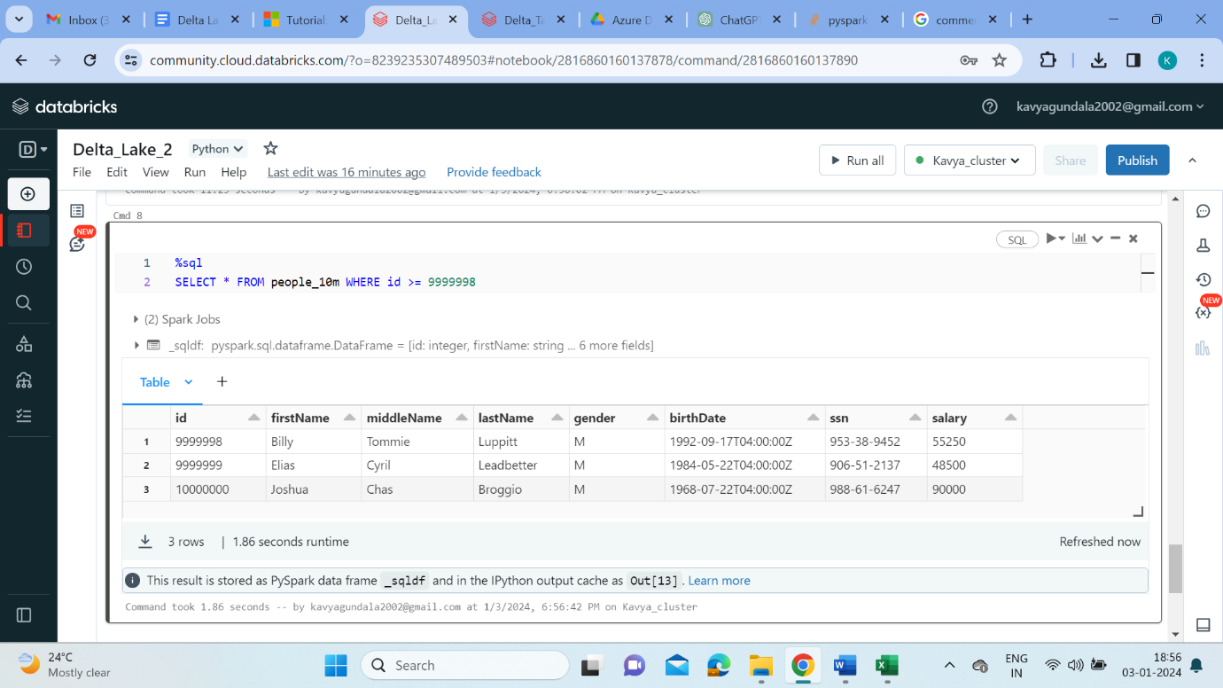

**Read from a table:**

* To retrieve all the data from table in SQL, use the below query.

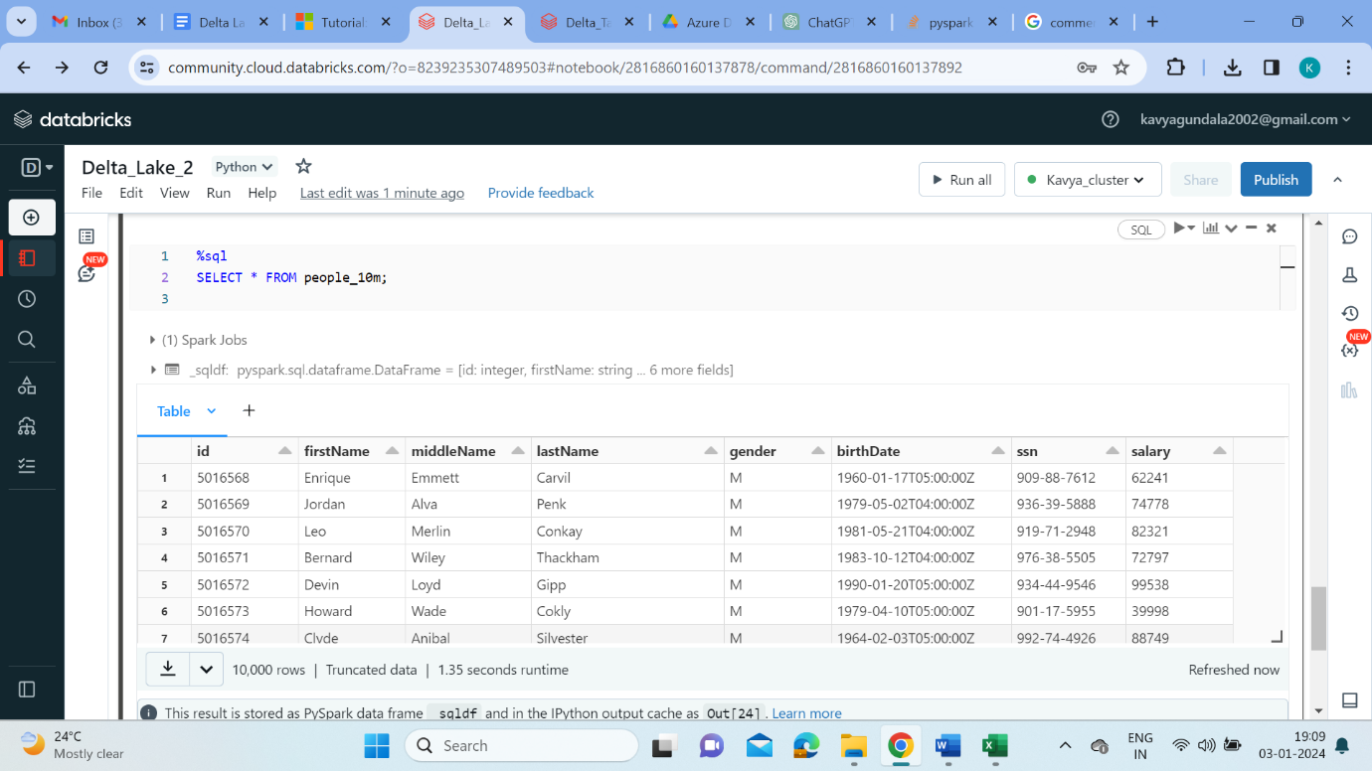

**Update a table:**

* Now update the table whenever the value ‘M’ and ‘F’ are encountered. Set the new values to ‘Male’ and ‘Female’.

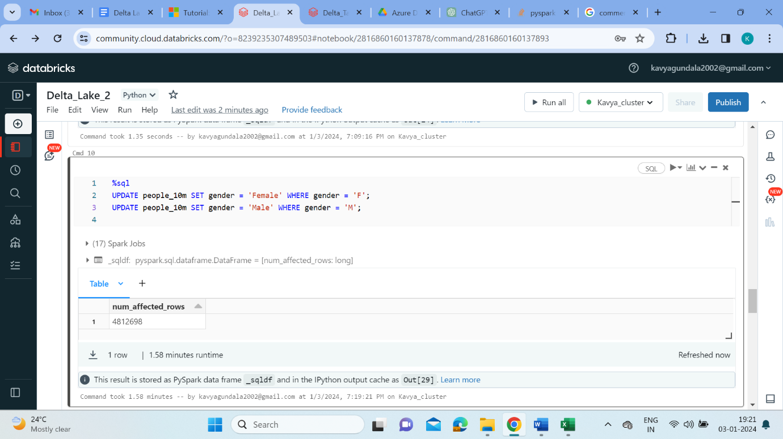

**Delete from a table:**

* The below query deletes the data where birthdate is less than ‘1995-01-01’.

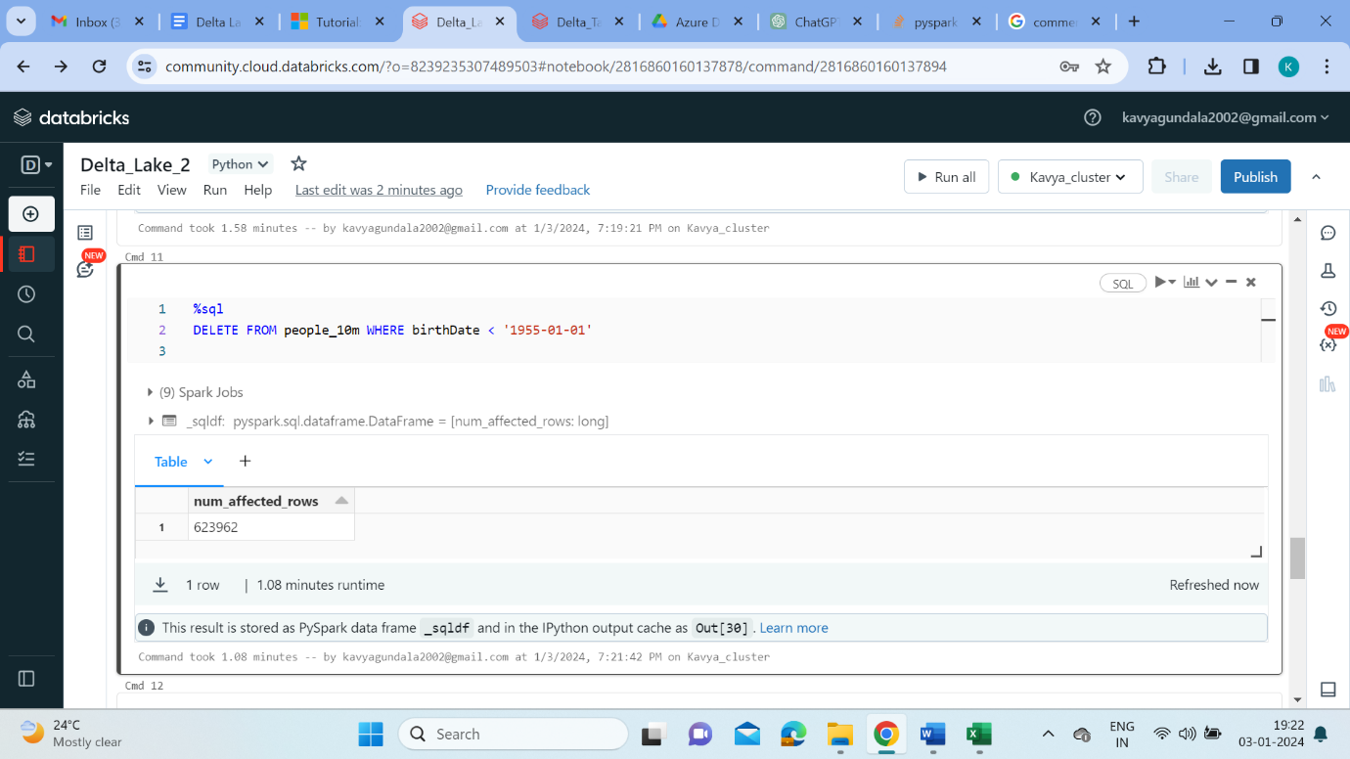

**Display history of the table:**

* We can look up the operations performed on the table starting from the creation of the table. For our table “people_10m” we performed Merge, Update, Delete operations.

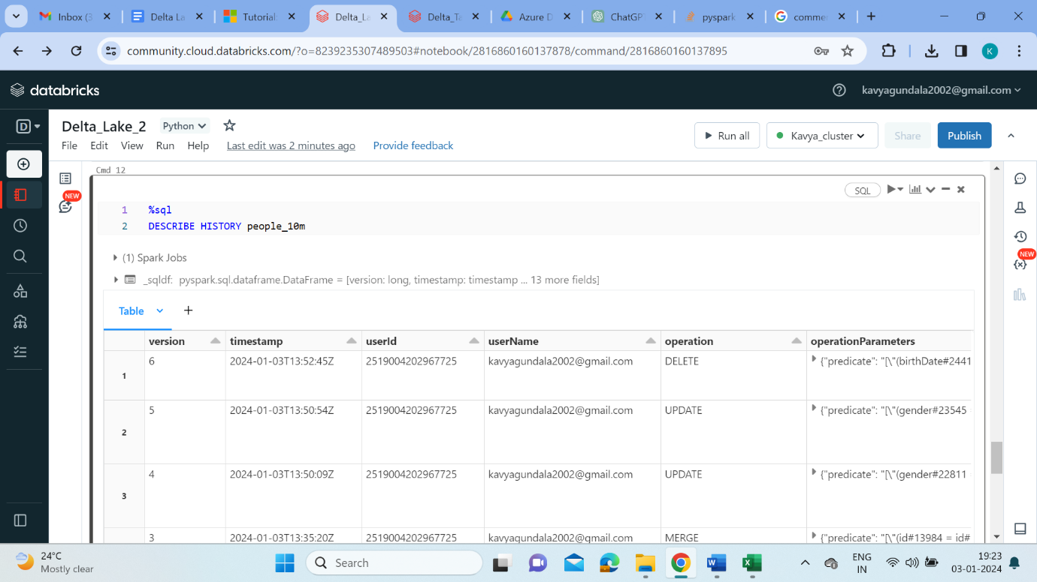

**Optimize the table:**

* Once we have performed multiple changes to a table, we might have a lot of small files. To improve the speed of read queries, we can use OPTIMIZE to collapse small files into larger ones:

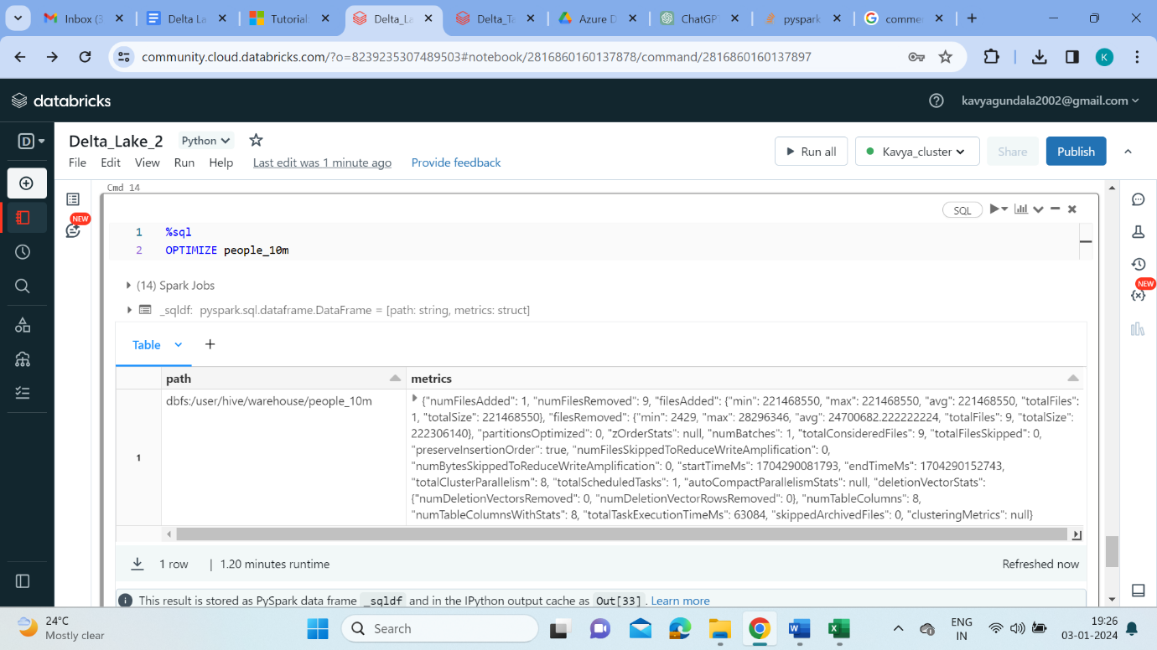

**Z-Order by Columns:**

* To optimize further by columns, we can optimizing the table using specified columns like the one given below.

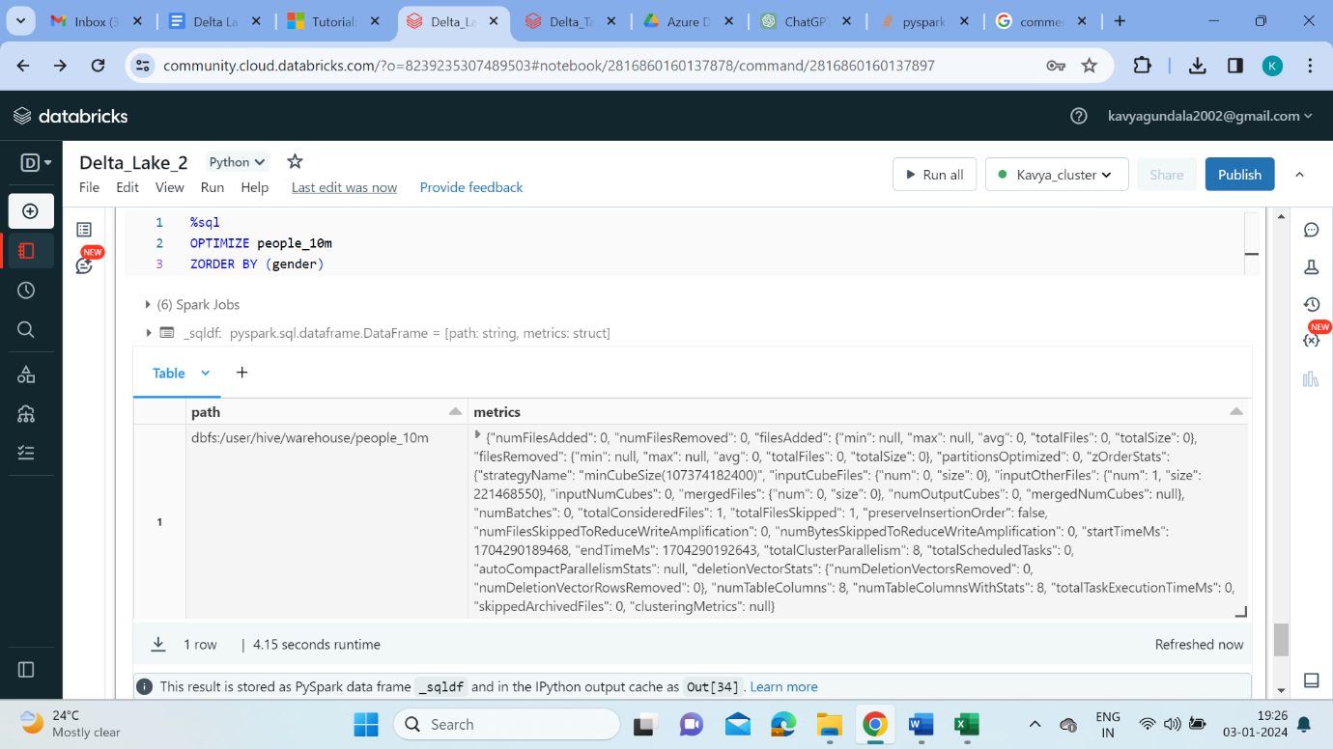

**Vacuum in Delta Lake:**

* Delta Lake provides snapshot isolation for reads, which means that it is safe to run OPTIMIZE even while other users or jobs are querying the table. Eventually however, we should clean up old snapshots. we can do this by running the VACUUM command:

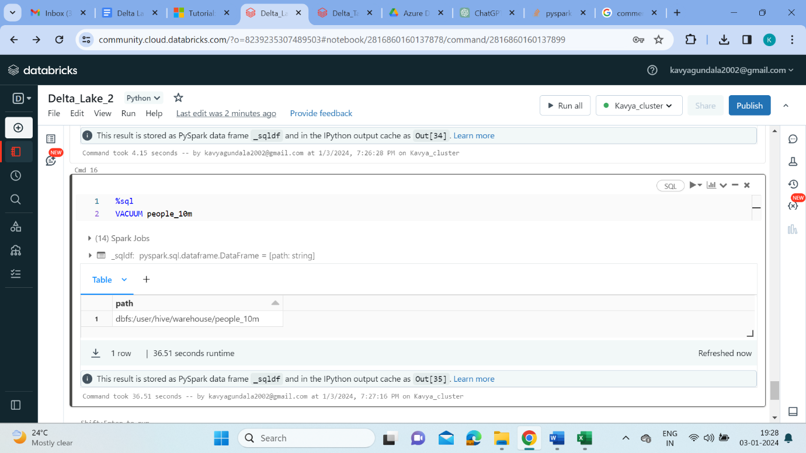

**Azure Data Lake Storage Generation2:**

* A data lake is a single, centralized repository where we can store all your data, both structured and unstructured. Azure Data Lake Storage is a cloud-based, enterprise data lake solution. It's engineered to store massive amounts of data in any format, and to facilitate big data analytical workloads. The data is imported and stored in Azure Data Lake Container.
* A data lake is a repository of data that is stored in its natural format, usually as blobs or files. A benefit of Data Lake Storage is that you can treat the data as if it's stored in a Hadoop Distributed File System (HDFS).

Benefits of Azure Data Lake Storage,

* Hadoop compatible access
* Security
* Performance
* Data redundancy

ADLS Gen1 is based on Hadoop Distributed File System (HDFS), while ADLS Gen2 is built on top of Azure Blob Storage. We use ADLS Gen2 for our workspace. Azure Data Lake Store Gen2 is an enabling technology for multiple data analytics use cases.

**Compare Azure Data Lake Store to Azure Blob storage:**

* In Azure Blob storage, you can store large amounts of unstructured ("object") data in a flat namespace within a blob container. Blob names can include "/" characters to organize blobs into virtual "folders", but in terms of blob manageability the blobs are stored as a single-level hierarchy in a flat namespace.

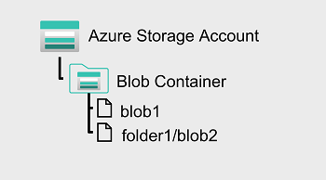

* Azure Data Lake Storage Gen2 builds on blob storage and optimizes I/O of high-volume data by using a hierarchical namespace that organizes blob data into directories, and stores metadata about each directory and the files within it.

**Stages for Processing Big Data:**

* Data lakes have a fundamental role in a wide range of big data architectures. These architectures can involve the creation of:
  + An enterprise data warehouse.
  + Advanced analytics against big data.
  + A real-time analytical solution.
* There are four stages in Processing big data.
  + **Ingest** - The ingestion phase identifies the technology and processes that are used to acquire the source data. This data can come from files, logs, and other types of unstructured data that must be put into the data lake.
  + **Store** - The store phase identifies where the ingested data should be placed. Azure Data Lake Storage Gen2 provides a secure and scalable storage solution that is compatible with commonly used big data processing technologies.
  + **Prep and train** - The prep and train phase identifies the technologies that are used to perform data preparation and model training and scoring for machine learning solutions. Common technologies that are used in this phase are Azure Synapse Analytics, Azure Databricks, Azure HDInsight, and Azure Machine Learning.
  + **Model and serve** - Finally, the model and serve phase involves the technologies that will present the data to users. These technologies can include visualization tools such as Microsoft Power BI, or analytical data stores such as Azure Synapse Analytics.

**Data Warehousing:**

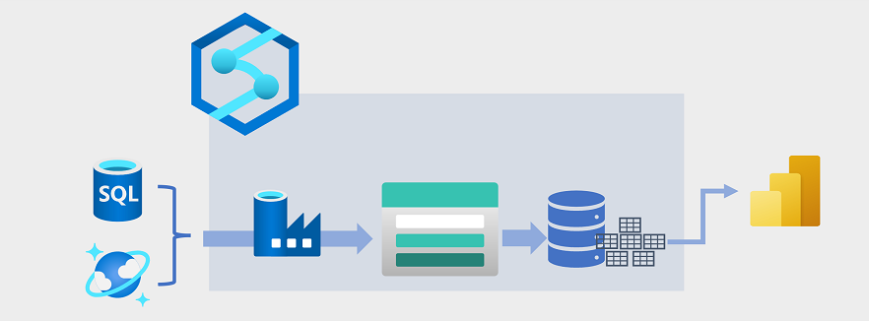

* Data warehousing has evolved in recent years to integrate large volumes of data stored as files in a data lake with relational tables in a data warehouse. In a typical example of a data warehousing solution, data is extracted from operational data stores, such as Azure SQL database or Azure Cosmos DB, and transformed into structures more suitable for analytical workloads.
* There are multiple ways to implement this kind of data warehousing architecture. The diagram shows a solution in which Azure Synapse Analytics hosts pipelines to perform extract, transform, and load (ETL) processes using Azure Data Factory technology.
* These processes extract data from operational data sources and load it into a data lake hosted in an Azure Data Lake Storage Gen2 container. The data is then processed and loaded into a relational data warehouse in an Azure Synapse Analytics dedicated SQL pool, from where it can support data visualization and reporting using Microsoft Power BI.

**Creation of Azure Data Lake Storage Access Gen2:**

* Open the Azure Portal, In the search bar, search for ‘Storage Account(classic)’. Start creating the resource named ‘kavyastorage’. In the Advance tab check the Hierarchical Namespace to access ADLS Gen2. And create the resource.

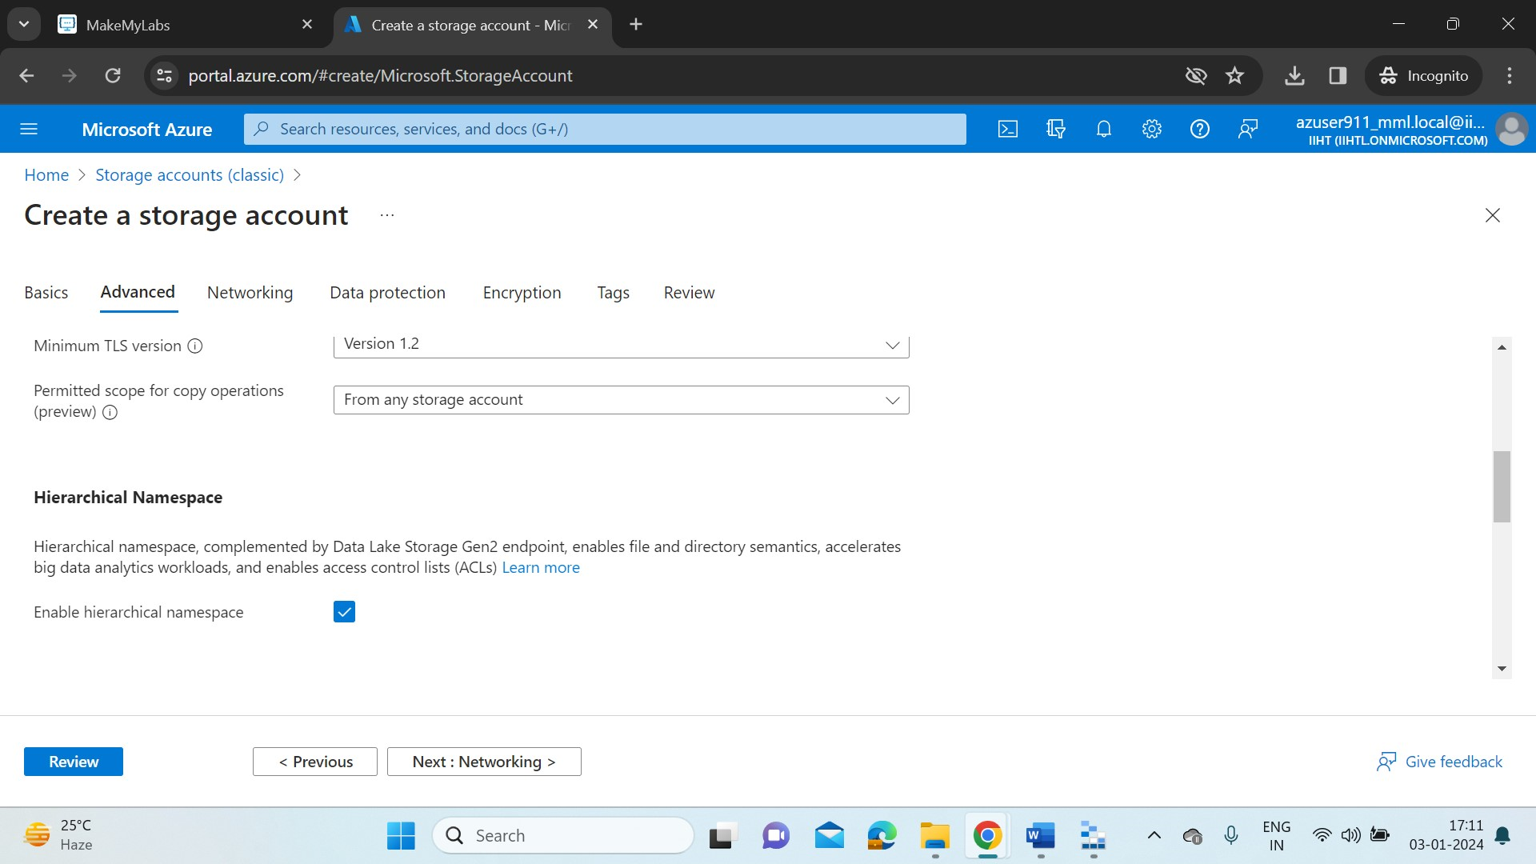

* After the deployment is success we can review it in Notifications section.

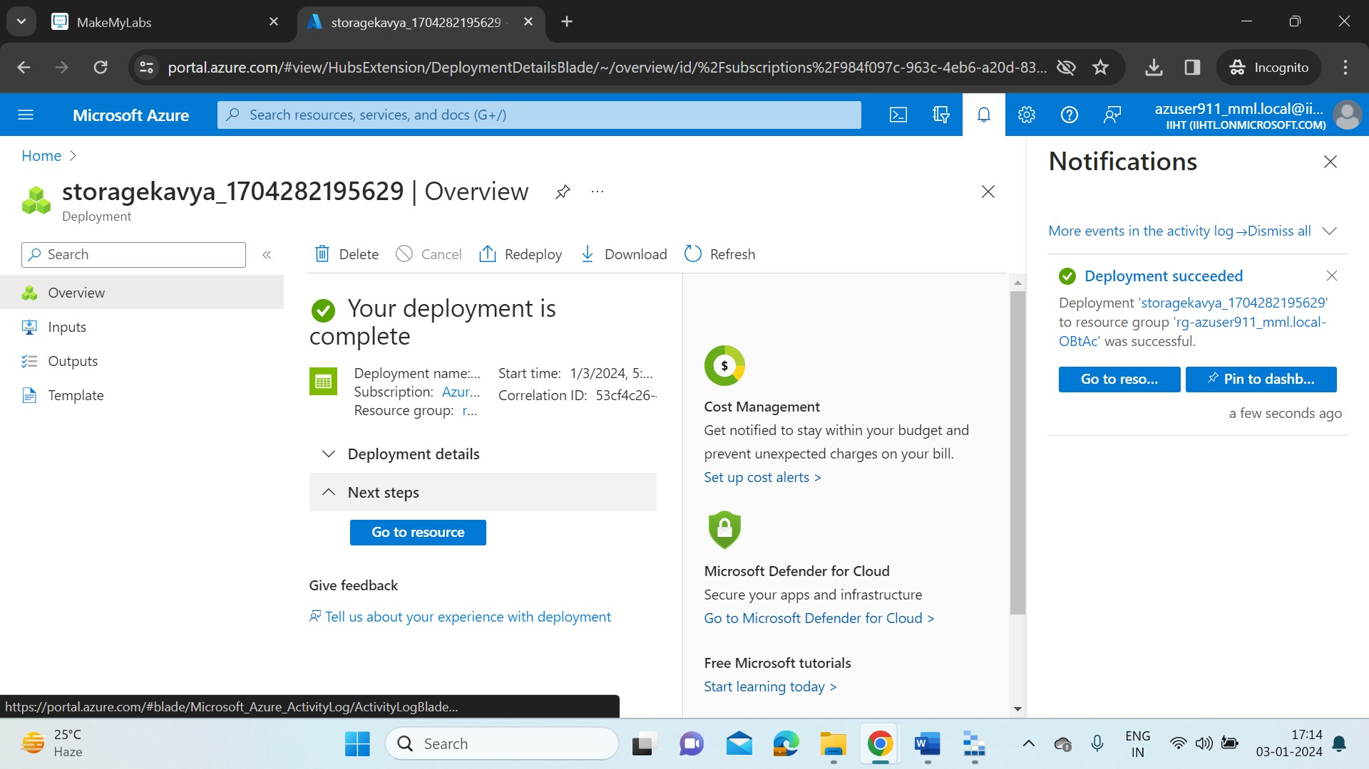

**Azure Storage Explorer:**

* Now download the Azure Storage Explorer into local system to access the Azure Services and create blobs, files. The link is

<https://azure.microsoft.com/en-us/products/storage/storage-explorer/>

* Now, Open the Azure Storage Explorer from local system.

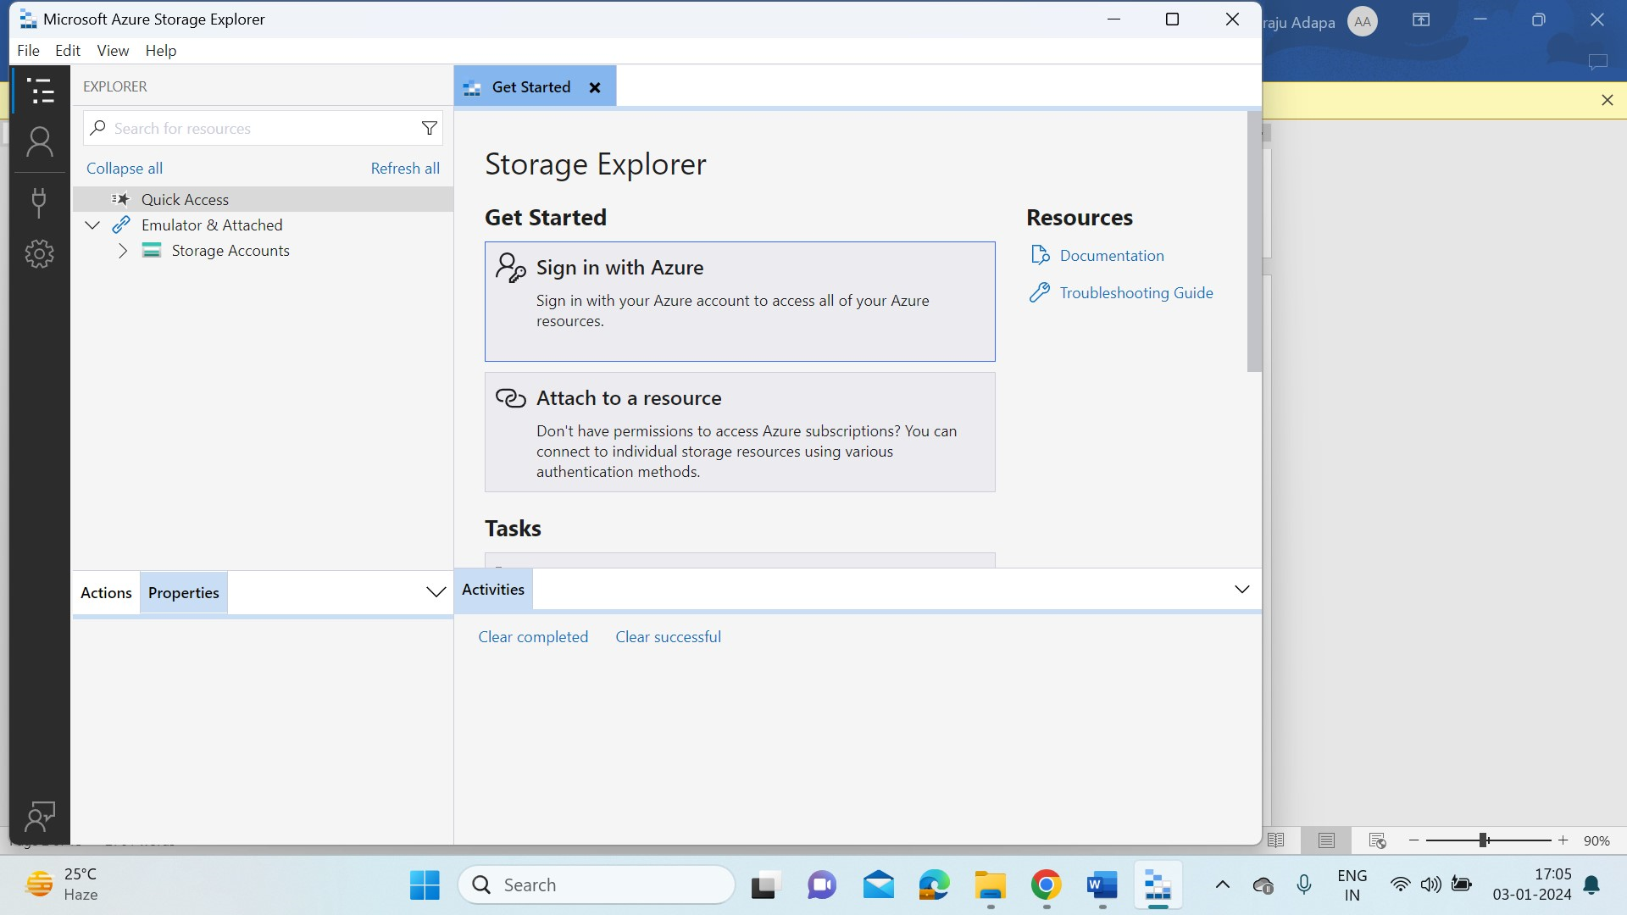

* Sign in with Azure account. It requires authentication and it is done in default browser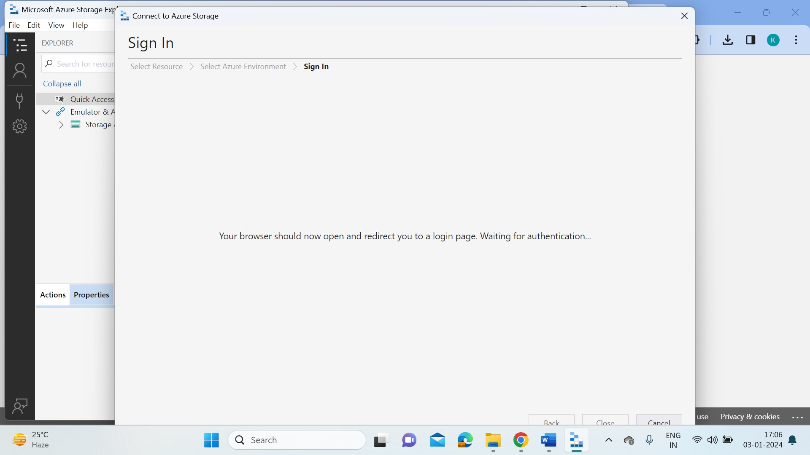

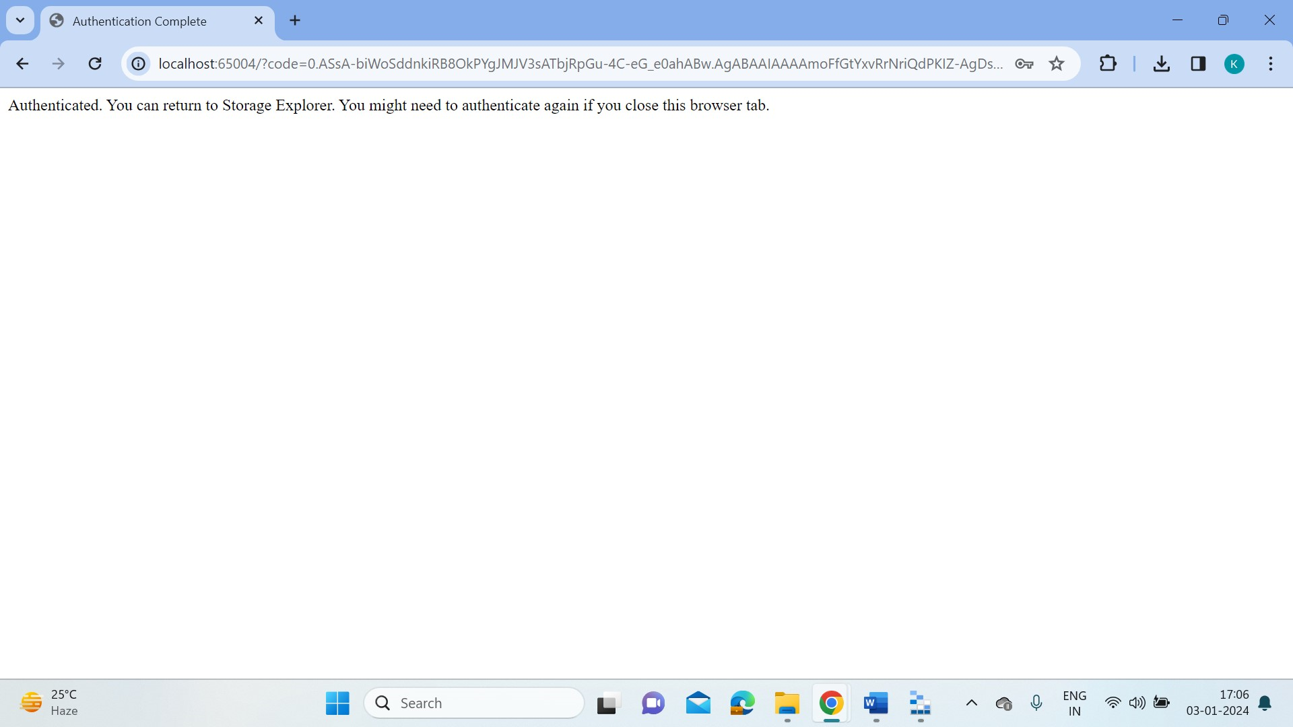

* After Authentication we can have a look of all our resources created in Azure in our local Azure Storage Explorer. Now go to the Storage Explorer and expand our subscription.
* Expand the storage account, and select Blob Containers.
* Right-click Blob Containers and select Create Blob Container.
* Under Blob Containers, enter salesdata.
* After the container is created, select salesdata.

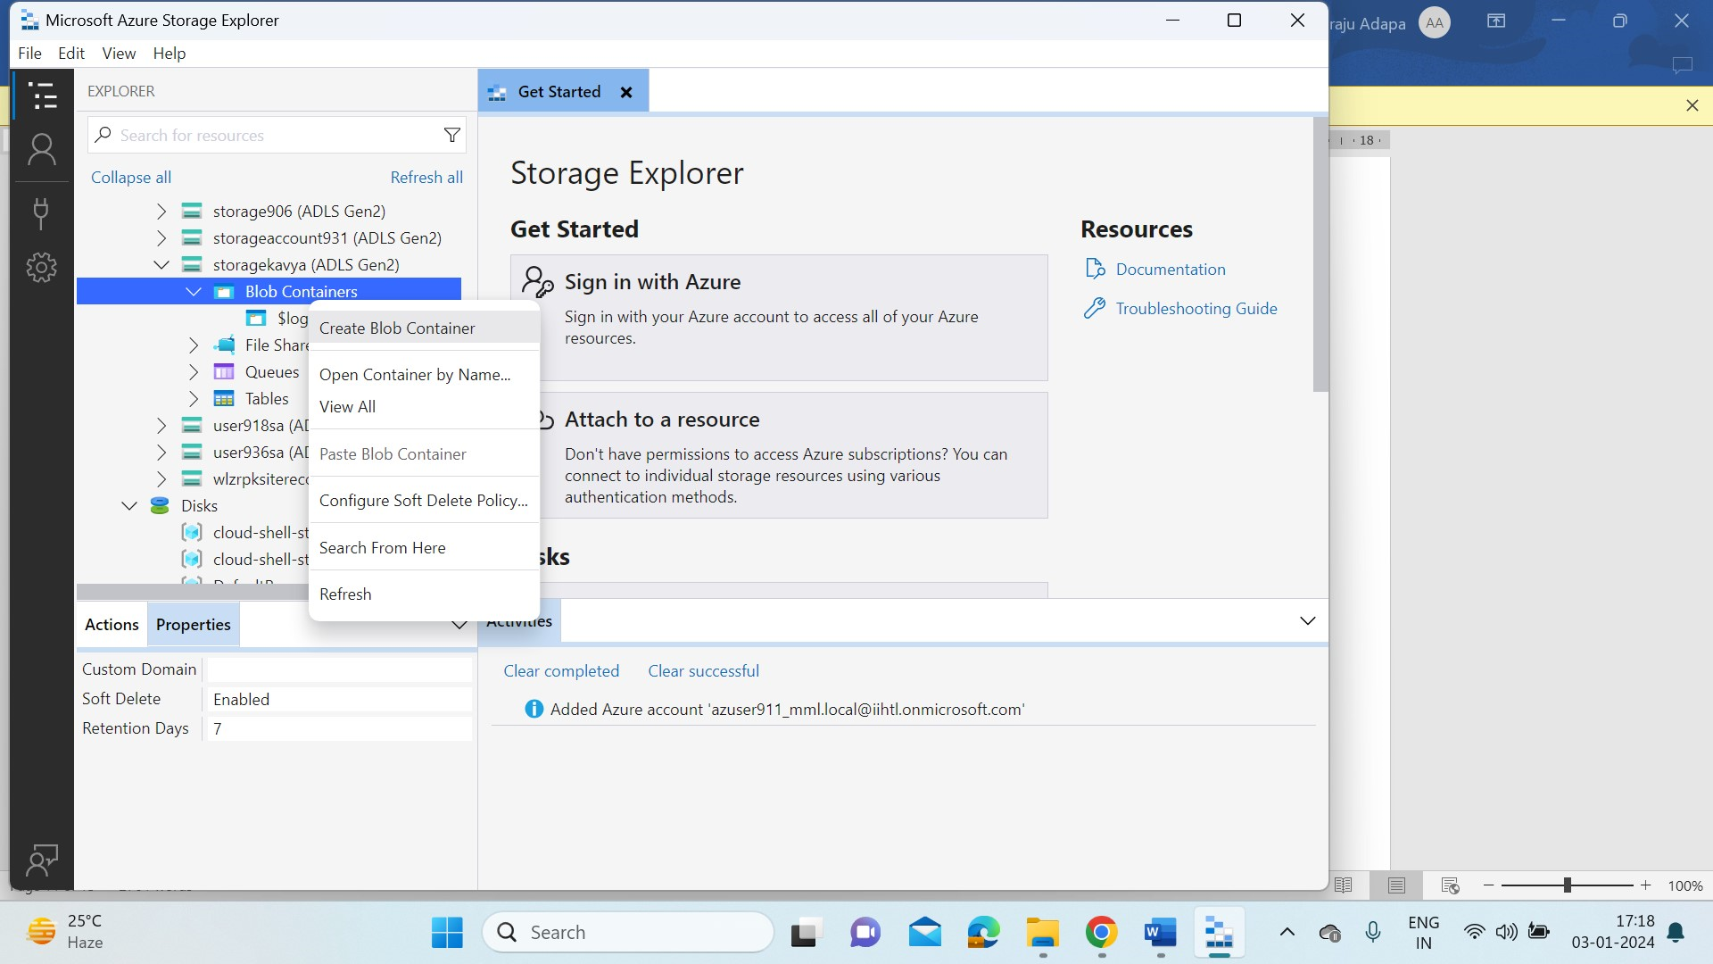

**Create a folder in a storage container:**

* On the menu at the top of Storage Explorer, select New Folder.
* Name the folder sample1. Then select OK to create the directory. If you get a message that asks if you want to refresh your view, select Yes.
* Double-click the new folder. This action traverses into the folder, which should be empty.
* Create another folder named data1.

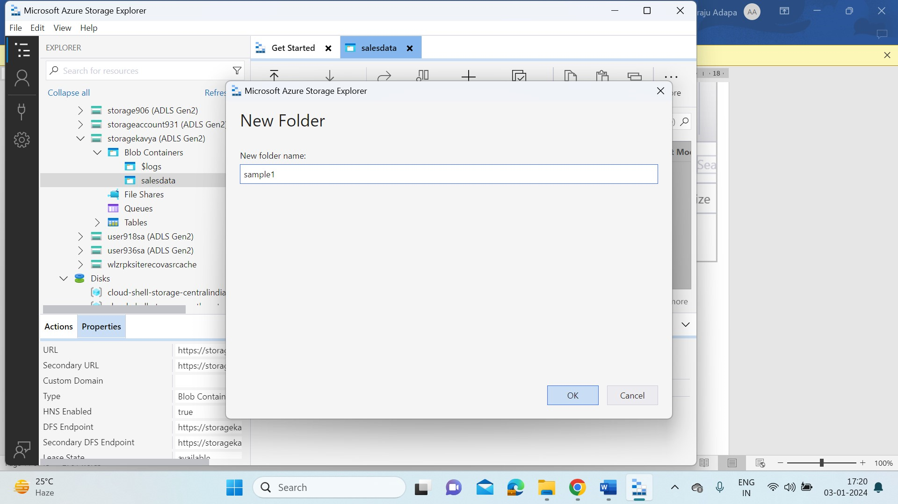

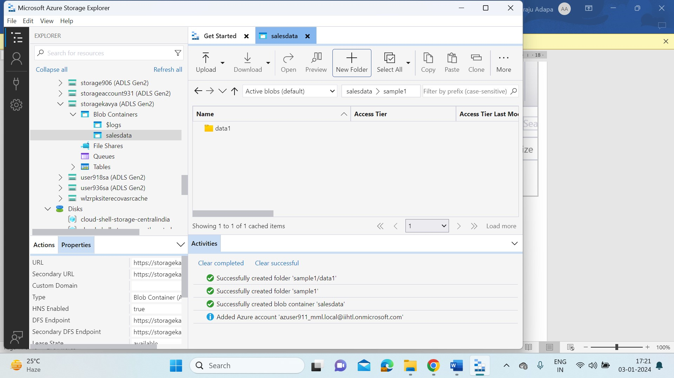

**Create a Sample text file:**

* In our local system , we create a sales.txt file.

**Upload the file:**

* In Storage Explorer, double-click the data folder.
* On menu at the top of the window, select Upload. From the Upload menu, you can upload a folder or a file.
* Select Upload Files.
* Select the sales.txt file you created earlier.
* In the Upload Files dialog box, ensure that the destination directory is sample/data. Then select Upload.

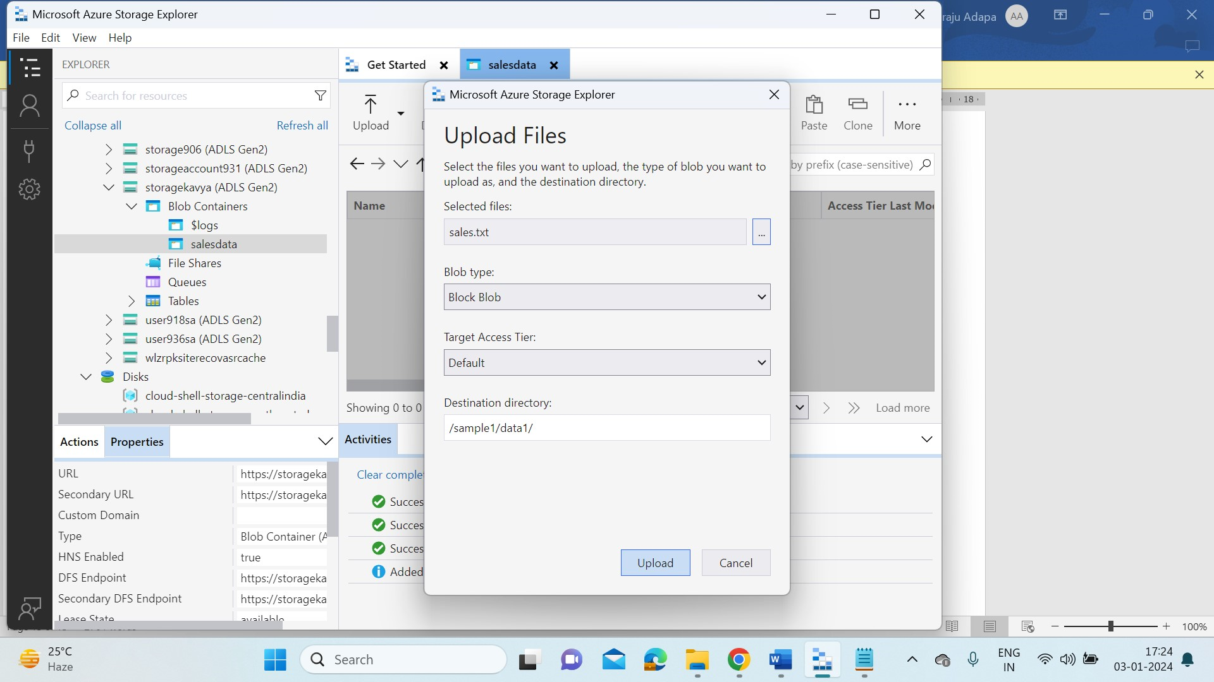

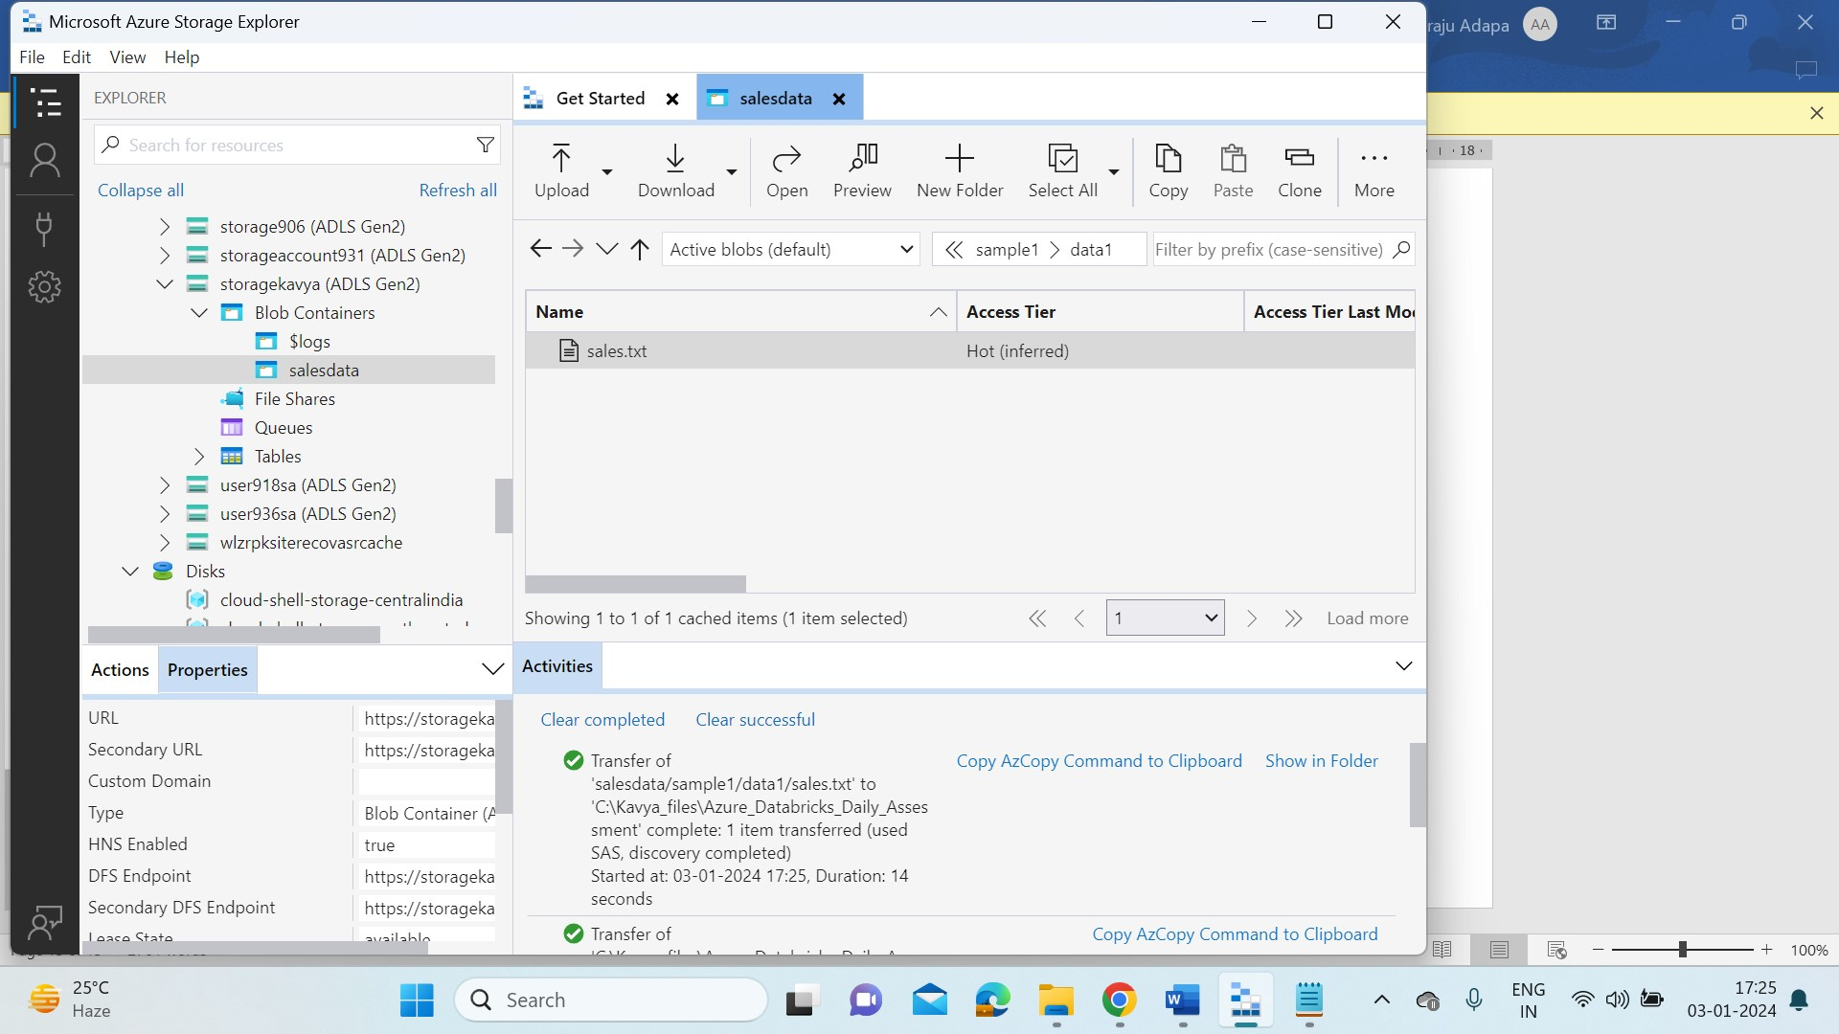

**Download a file:**

* To download a copy of a file ,

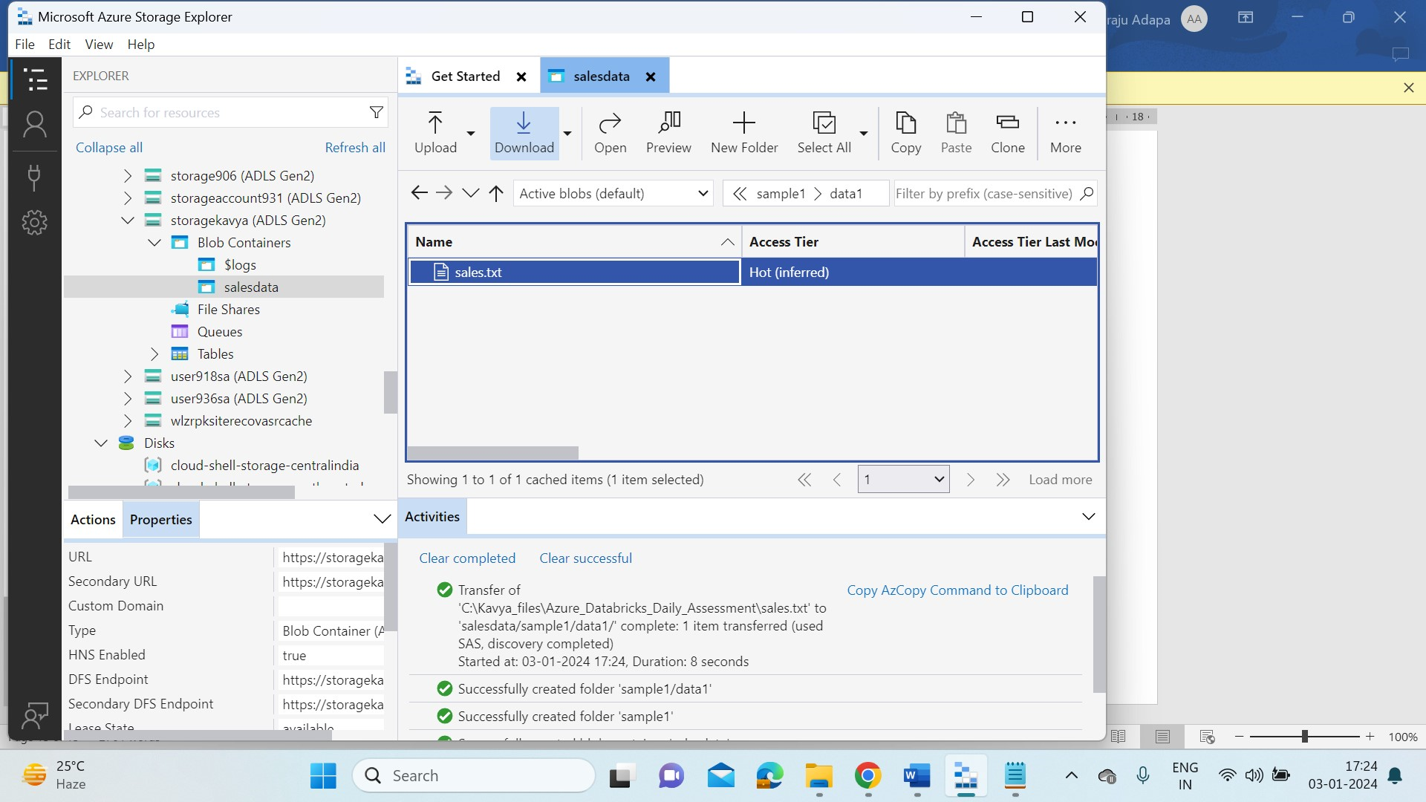

* We can always look the activities that are performed in the Storage Explorer, in the down Activities tab.
* In the below picture we can see the files that are uploaded in Storage Explorer reflects in our Azure Portal too.

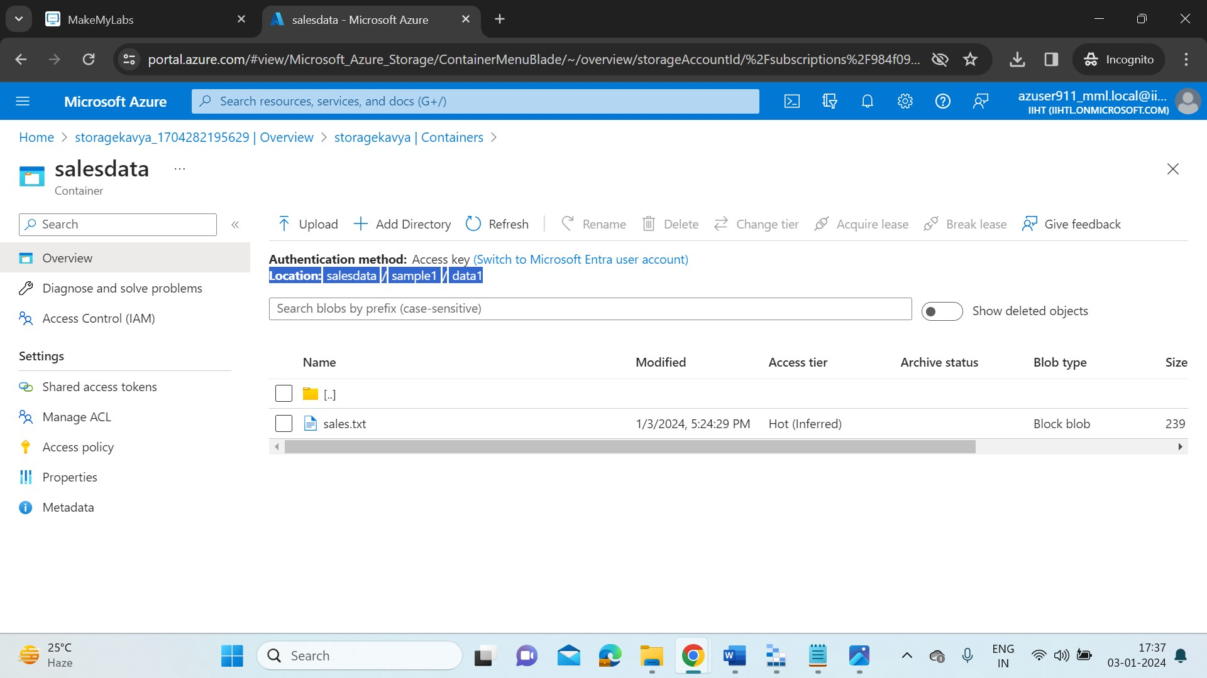

* It is always best practice to delete the no longer required resources to avoid billing costs.

